Chain of Responsibility Pattern
# Source: AI Source: Provided by: [Data Path: Persons Table -> ID Column: 1, Name_En Column: Motasem Essam] -> From: [ChatGPT] on [1/23/2026]
The Chain of Responsibility Pattern allows a request to be passed along a chain of handlers, where each handler decides either to process the request or pass it to the next handler.
👉 Think of it like customer support escalation: if the first agent can’t solve your issue, it gets passed to a supervisor, then maybe to a manager.

🔑 Key Points
# Source: AI Source: Provided by: [Data Path: Persons Table -> ID Column: 1, Name_En Column: Motasem Essam] -> From: [ChatGPT] on [1/23/2026]
• Multiple handlers form a chain
• Each handler decides to handle or pass the request
• Decouples sender from receiver
• Supports flexible request processing

❌ Bad Example
# Source: AI Source: Provided by: [Data Path: Persons Table -> ID Column: 1, Name_En Column: Motasem Essam] -> From: [ChatGPT] on [1/23/2026]
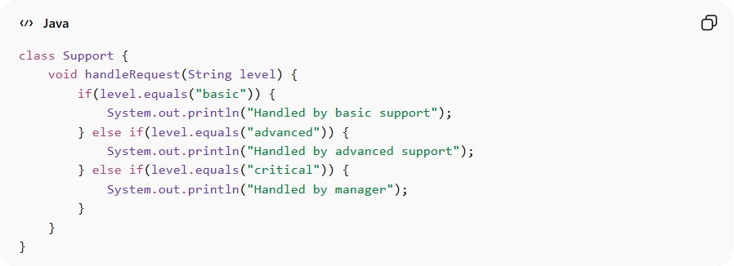
class Support {
void handleRequest(String level) {
if(level.equals("basic")) {
System.out.println("Handled by basic support");
} else if(level.equals("advanced")) {
System.out.println("Handled by advanced support");
} else if(level.equals("critical")) {
System.out.println("Handled by manager");
}
}
}
Problems:
• Uses if/else chains
• Violates Open/Closed Principle
• Hard to extend with new levels

✅ Good Example
# Source: AI Source: Provided by: [Data Path: Persons Table -> ID Column: 1, Name_En Column: Motasem Essam] -> From: [ChatGPT] on [1/23/2026]
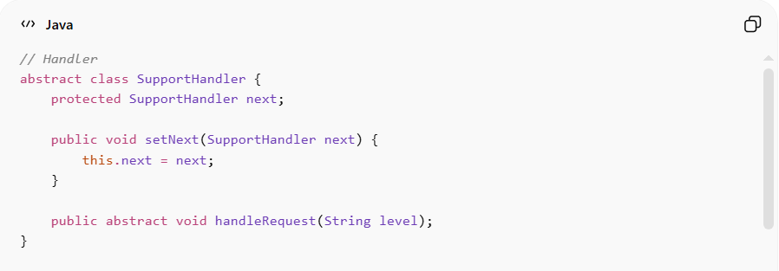
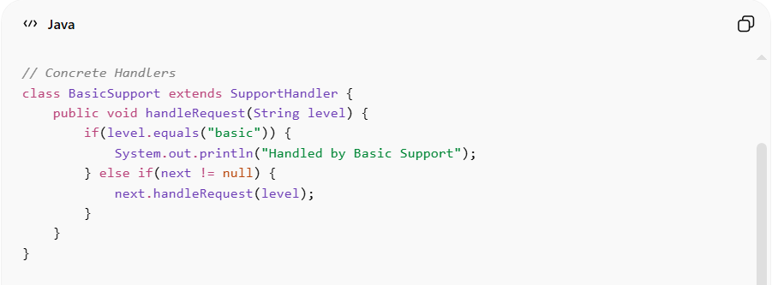
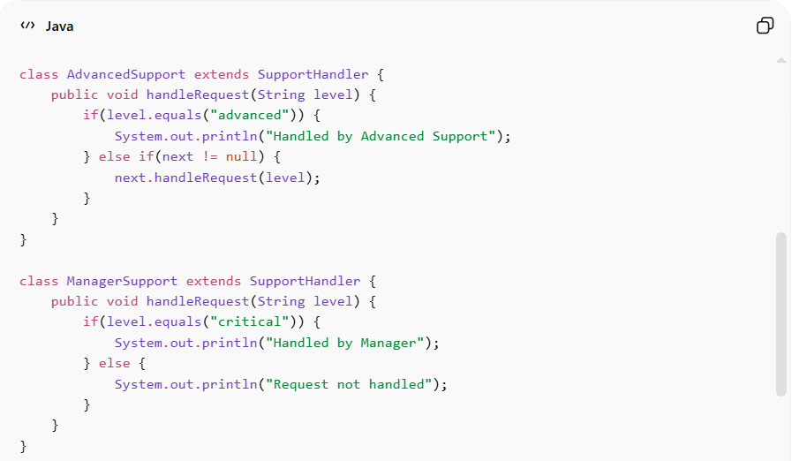
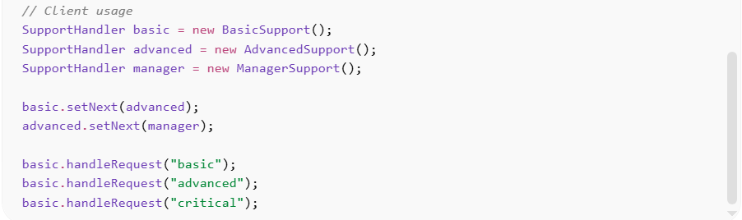
// Handler
abstract class SupportHandler {
protected SupportHandler next;

public void setNext(SupportHandler next) {
this.next = next;
}

public abstract void handleRequest(String level);
}

// Concrete Handlers
class BasicSupport extends SupportHandler {
public void handleRequest(String level) {
if(level.equals("basic")) {
System.out.println("Handled by Basic Support");
} else if(next != null) {
next.handleRequest(level);
}
}
}

class AdvancedSupport extends SupportHandler {
public void handleRequest(String level) {
if(level.equals("advanced")) {
System.out.println("Handled by Advanced Support");
} else if(next != null) {
next.handleRequest(level);
}
}
}

class ManagerSupport extends SupportHandler {
public void handleRequest(String level) {
if(level.equals("critical")) {
System.out.println("Handled by Manager");
} else {
System.out.println("Request not handled");
}
}
}

// Client usage
SupportHandler basic = new BasicSupport();
SupportHandler advanced = new AdvancedSupport();
SupportHandler manager = new ManagerSupport();

basic.setNext(advanced);
advanced.setNext(manager);

basic.handleRequest("basic");
basic.handleRequest("advanced");
basic.handleRequest("critical");
Benefits:
• Removes complex conditional logic
• Allows dynamic chain configuration
• Promotes flexibility and scalability
• Decouples sender from handler

⚡ Advantages
# Source: AI Source: Provided by: [Data Path: Persons Table -> ID Column: 1, Name_En Column: Motasem Essam] -> From: [ChatGPT] on [1/23/2026]
• Reduces coupling between sender and receivers
• Easy to add new handlers
• Supports dynamic request processing
• Improves code maintainability

⚠️ Disadvantages
# Source: AI Source: Provided by: [Data Path: Persons Table -> ID Column: 1, Name_En Column: Motasem Essam] -> From: [ChatGPT] on [1/23/2026]
• Request may go unhandled if no handler processes it
• Can be hard to debug long chains
• May introduce performance overhead

🛠️ Use Cases
# Source: AI Source: Provided by: [Data Path: Persons Table -> ID Column: 1, Name_En Column: Motasem Essam] -> From: [ChatGPT] on [1/23/2026]
• Logging frameworks – different log levels (info, warning, error)
• Authentication/authorization pipelines
• Event handling systems
• Customer support systems

